EXPERIMENT-1
ROLL NO:240701437 NAME:Rohith Nikethan USER INTERFACE AND DESIGN
COMAPARSION OF UI DESIGN BETWEEN TWO FIGMA CREATION

BAD WEBSITE: 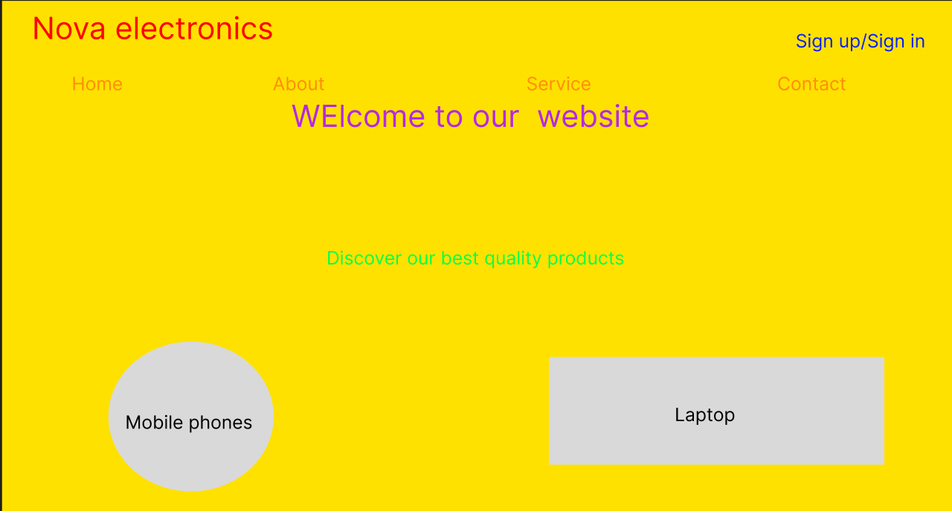

Good website: 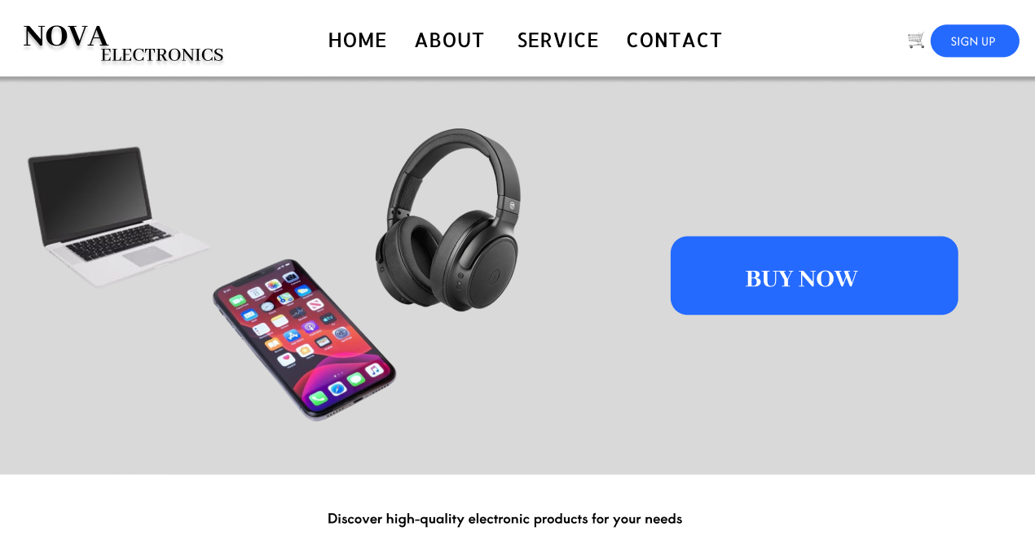

PROTOTYPE LINK:
https://www.figma.com/proto/rLOz5VZMGdw4AJTJAvtBY9/Untitled?node-id=0-1&t=sxoP6x9vpPzZOlxG-1
The two websites have distinct designs and approaches. Here's a comparison:
1.Color System
Bad Design Issue
Clashing neon colors no color meaning, difficult to read, causes eye strain
Good Design Solution
primary blue , neutral grays, contrast ratios for accessibility
2. Navigation
Bad Design Issue
Inconsistent sizing, rotated links, links hidden or unclear, no logical grouping
Good Design Solution
Clear, consistent navigation bar, logical menu structure.
3. User Experience
Bad Design Issue
Annoying popups, floating elements blocking content, poor form design
Good Design Solution
clear focus indicators, no intrusive elements, proper form labels and validation
4.Responsive Design
Bad Design Issue
Fixed layouts that break on mobile, text becomes illegible, elements overlap making interaction impossible
Good Design Solution
Mobile-first approach with breakpoints ,flexible grids, touch-friendly tap targets

Design Principles Applied
The good design follows established UX principles that have been proven through research and practice
1.Consistency
Every element follows predictable patterns same button styles, consistent spacing, uniform typography
2.Visual Hierarchy
Information is prioritized through size, weight, color, and placement guiding users naturally
3.Whitespace
Generous breathing room around elements improves comprehension and reduces cognitive load
4.Alignment
Elements align to a grid creating order and professionalism - no random rotations or offsets
5.Color Psychology
Blue conveys trust and professionalism, grays provide neutrality, accent colors guide attention
6.Progressive Disclosure
Information is revealed as needed, not all at once reducing overwhelm

